**GEOGRAPHIC INFORMATION SYSTEMS 1 – SCIENTIFIC DATA**

**UMEÅ UNIVERSITY – DEPARTMENT OF ECOLOGY & ENVIRONMENTAL SCIENCE**

**LAB2 – ASSIGNMENT 2**

**LAB2.1 Reading Comprehension**

**LAB2.2 Lab2 questions**

**LAB2.3 ArcGIS maps**

**LAB2.4 Map questions / extra data**

**LAB2.1 – READING COMPREHENSION**

**Mapping geomorphology: A journey from paper maps, through computer mapping to GIS and Virtual Reality. John D. Vitek, John R. Giardino, Jeffrey W. Fitzgerald, 1995.**

**LAB2.1.1**

**Based on the article by Vitek et al. (1996)** 1**, give one pro and one con of making maps using computers (i.e., GIS) as compared to ‘old-fashioned’ techniques with pen and paper.**

A considerable number of pros and cons about of the use of computers for maps production could be obviously mentioned. I would say though that there a significant number of pros and only one big con. Therefore, I will try to summarise them into the following:

**1.** **Efficiency** for both map producer and user could be considered as the main **pro**. Efficiency is given during the GIS process by different factors, some of which are mentioned below:

1.1 Ease and rapidity of **data input** 2,3, either through digitation of existing maps or by production of new data.

1.2 Best **data storage and management** 2,3, which is extraordinarily better than pen-and-paper maps.

1.3 Outstanding quality of **data visualisation and output** 2,3.

1.4 Ease of **data manipulation and analysis** 2,3.

1.5 Enhancement of **user interface** 2,3, *“Prices continue to decrease on hardware and software while the consumer becomes more sophisticated and better products continue to emerge”* 2.

**2.** When it comes to **cons**, there is a **lack of attention to basic mapping concepts such as projection, scale, generalization and symbolization** 4. As the analysed article mentions: *“awareness of basic mapping concepts, including symbolization, projections, scale, and generalization, must be re-introduced into the curriculum rather than left to chance”* 4. Further training should be obviously taken, not only in GIS tools and geospatial data analysis, but also in these basic mapping concepts. In my personal experience of having produced pen-and-paper drawings, in which the drawing is directly produced at the output scale, the production of computer-aided drawings does have a lack of sense of scale in many cases. It can’t be denied that this is one of the main difficulties and risks of drawing in front of a screen.

**LAB2.1.2**

**Imagine John Snow had access to ArcGIS during the cholera epidemic in 1854. Using bullet points, give brief step-by-step instructions on: (1) which data he would have needed and describe if they would be points, lines, or polygons, (2) describe the steps he would have followed and (3) tools he would have used in ArcGIS to solve the crisis.**

**(1) Describe which data he would have needed and if they would be points, lines, or polygons.**

At least the datasets or layers below could have been needed:

Layer1 / Polygons Base Map of the area affected by the cholera outbreak, which should include the building blocks that give a shape to the urban area.

Layer2 / Points Streets labels layer, which can be relevant for the map users to find out the location of events.

Layer3 / Polygons Cadastral Map, which should include attributes for each property, such as a property unique code, address (street and number), type of property (residential buildings, community facilities, business premises, etc.), number of people registered at the property, and so on.

Layer4 / Lines Sewage water network

Layer5 / Lines Water supply network (legal or illegal)

Layer6 / Points Water wells

Layer7 / Points People affected by the disease (he would probably know data only about people who had already dead). This dataset should include attributes for each record, such as address or property unique code of the property in which these people are registered, age, occupation, school or work address (which would show the place where they spend a considerable part of the day), and so on.

**(2) Describe the steps he would have followed.**

Step 0 Obviously, **GIS-training**5 shouldn’t be ignored, since this is essential for any of the following steps. However, it could be assumed that he was knowledgeable of GIS-software, tools, all manipulation and analyses techniques, and all input and output peripheral, which are absolutely needed to undertake this type of task.

Step 1 **Digitising and scanning**. Base maps, which did exist on paper, could have been digitised by using a **scanner** in order to digitally store them 6. It should be obviously taken into account that paper maps have a constant size and a specific scale. It should be assumed that a generalisation or simplification has already been done according to this scale. Thus, unless further detail is added from other sources, this should be the output scale at the end of the process. Also an aerial image could have been used for this purpose. In this case, a **special tracing table** should have been used in order to trace a map over the aerial image 6.

Step 2 **Manipulating**.

2.1 **Data storage** 6. Digitised maps (each of which would be a dataset) should have been conveniently stored. To do this, a **geodatabase** could have been produced by using ArcCatalog, so that all datasets could be stored in it, and also a unique projection system could be granted for the whole database.

2.2 Display in ArcMap. These datasets could be inserted in a data frame in ArcMap as layers.

Step 3 **Analysis** 6. Different operations could have been made in order to support any hypothesis or to look for new ones. ArcToolbox would have help with these operations.

Step 4 **Displaying** 5. By using the ArcMap layout, a sheet with the required size and scale could have been produced, where clusters of people affected by the cholera outbreak could have been shown. After operations made with ArcToolbox, a thematic map could have been shown, where city blocks were depicted according to the number of people affected within them.

Step 5 **Analysis results output** 5. Not only could the results have been physically printed, but also they could have been saved as a PDF in order to be displayed on a computer, presented in a meeting with local authorities, or included in a report as figures.

Step 6 **Decision-making** 5. The data obtained as a result of this analysis should have been used to find out the origin of the outbreak, so that a rapid decision could have been taken as soon as possible in order to save lives.

**(3) Describe the tools he would have used in ArcGIS to solve the crisis.**

ArcCatalog Data can be conveniently **stored and manipulated** through ArcCatalog, where a geodatabase could be created in order to store all the datasets in the same location and same projection system.

ArcMap By inserting datasets in a data frame, he could have **overlaid different maps**, which could have been one of the first tools to help visualise the spatial relationships between the different datasets.

By using ‘**Join**’, layers 3 and 7 described previously could have joined their data, so that the number of deceased people per blocks could be figured out.

Given that number of people and number of deceased people would be then in the same attributes table, a **new field** that showed the percentage of deceased people by block could have been shown.

**Thematic maps** can be produced by combining original and created layers, in which most affected areas would be shown. This could have given a first idea where the cholera outbreak was located.

ArcToolbox A number of the **ArcToolbox** tools could have been used to determine certain spatial relationships.

By making **Buffers** of a certain distance to layer 6 described previously, he could have figured out the number of deaths produces within the area of influence of each water well.

The tool **Merge** could have offered the chance to calculate total number of deaths per block, which could be compared with the total number of residents per block.

Statistics By **summarising statistics** of different fields within different datasets, he could have extracted schedules and diagrams to present them to the local authorities, in order to convince them about the ongoing epidemy.

Layout By using the layout tools, maps for **printing**, for **digital presentations**, or for inserting as **figures** in dossiers could have been produced, which could have been presented to local authorities, in order to solve the problem as fast as possible.

**REFERENCES**

1. Vitek, J.D., Giardino, J.R. & Fitzgerald, J.W. (1996). Mapping geomorphology: A journey from paper maps, through computer mapping to GIS and Virtual Reality. Geomorphology, Vol. 16, No. 3, pp. 233-249.
2. Vitek, J.D., Giardino, J.R. & Fitzgerald, J.W. (1996). Mapping geomorphology: A journey from paper maps, through computer mapping to GIS and Virtual Reality. Geomorphology, Vol. 16, No. 3, p. 240.
3. Burrough PA. Principles of Geographic Information Systems for Land Resource Assessment, Monographs on Soil and Resources Survey No. 12. New York: Oxford Science Publications; 1986.
4. Vitek, J.D., Giardino, J.R. & Fitzgerald, J.W. (1996). Mapping geomorphology: A journey from paper maps, through computer mapping to GIS and Virtual Reality. Geomorphology, Vol. 16, No. 3, p. 234.
5. Vitek, J.D., Giardino, J.R. & Fitzgerald, J.W. (1996). Mapping geomorphology: A journey from paper maps, through computer mapping to GIS and Virtual Reality. Geomorphology, Vol. 16, No. 3, p. 245.
6. Vitek, J.D., Giardino, J.R. & Fitzgerald, J.W. (1996). Mapping geomorphology: A journey from paper maps, through computer mapping to GIS and Virtual Reality. Geomorphology, Vol. 16, No. 3, pp. 243-244.

**LAB2.2.1**

**In this lab you’ll be creating a lot of new files, and sometimes it can be hard to keep track of what you have done and what files contains which data. So, for this lab you will need to create a meta-data file, which contains a table that has information about your data. Use Excel or Word to make a table that you update throughout the lab. The table should contain five columns:**

**(1) name of file,**

**(2) projection/coordinate system,**

**(3) a description of the data in the file,**

**(4) source (is the file taken directly from the original ‘GIS1_Lab2_data’ folder or is it created from another file, if so, which one),**

**(5) and tool/method used (if it was created from another file, which tool or steps did you take to create the file?; you don’t need to write anything here if it was one of the original files).**

A preview of the created excels schedule, which includes received and created files and their details, can be seen hereunder, as well as in an excel file included in the submission in the Drop Box.

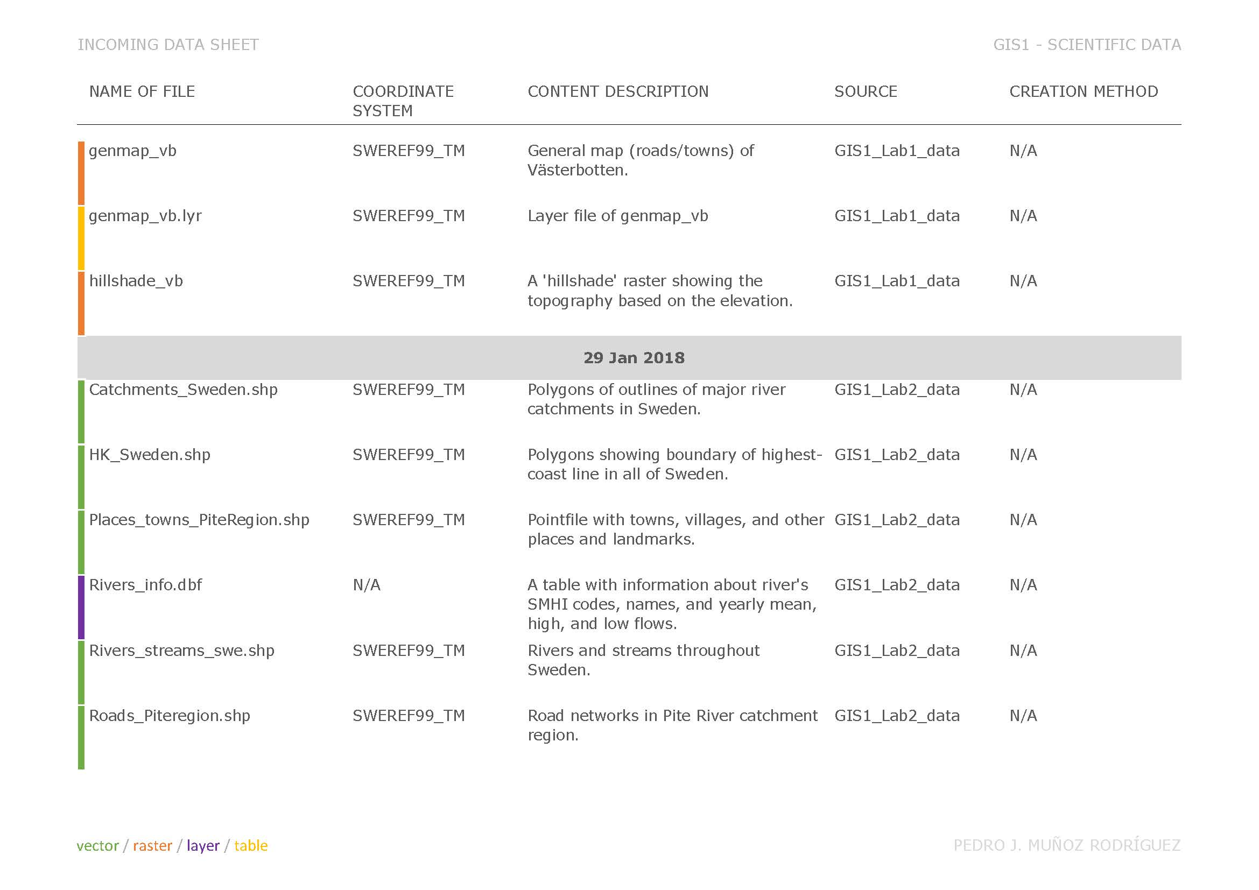

**LAB2.2.2**

**Past studies have found that the percentage of various compounds, including calcium carbonate, can differ between soils above and below the highest-coast line. Do these data within the Pite River catchment support that observation? Calculate the mean for the soil samples above and below the HCL for the following compounds: aluminium oxide (AL2O3), calcium carbonate (CAO), and iron (FE2O3). Report these values in a table.**

After summarising statistics of the file ‘Soil_Chorizon_Norrland_SWEREF99_TM.shp’, it could be said that the differences suggested by past studies are probably incorrect. We can see in the table below, that percentages of calcium carbonate of both sides of the highest coast line are pretty similar.

|  |  |  |  |  |
| --- | --- | --- | --- | --- |
| LOCATION (above or below HK) | FREQUENCY | SUM_CAO | MEAN_CAO | RANGE_CAO |
| **Above** the highest coast line | 805 | 1548,57 | 1,923689441 | 5,67 |
| **Below** the highest coast line | 805 | 1548,57 | 1,923689441 | 5,67 |

However, in the table below, we can see considerably bigger differences of mean values of Fe2O3, depending on the side of the highest coast line.

|  |  |  |  |  |  |
| --- | --- | --- | --- | --- | --- |
| LOCATION above / below HK | FREQUENCY |  | MEAN_**AL2O3** | MEAN_**CAO** | MEAN_**FE2O3** |
| **Above** the highest coast line |  | 21 | 12,72 | 1,88 | 4,46 |
| **Below** the highest coast line |  | 11 | 12,75 | 1,95 | 3,85 |

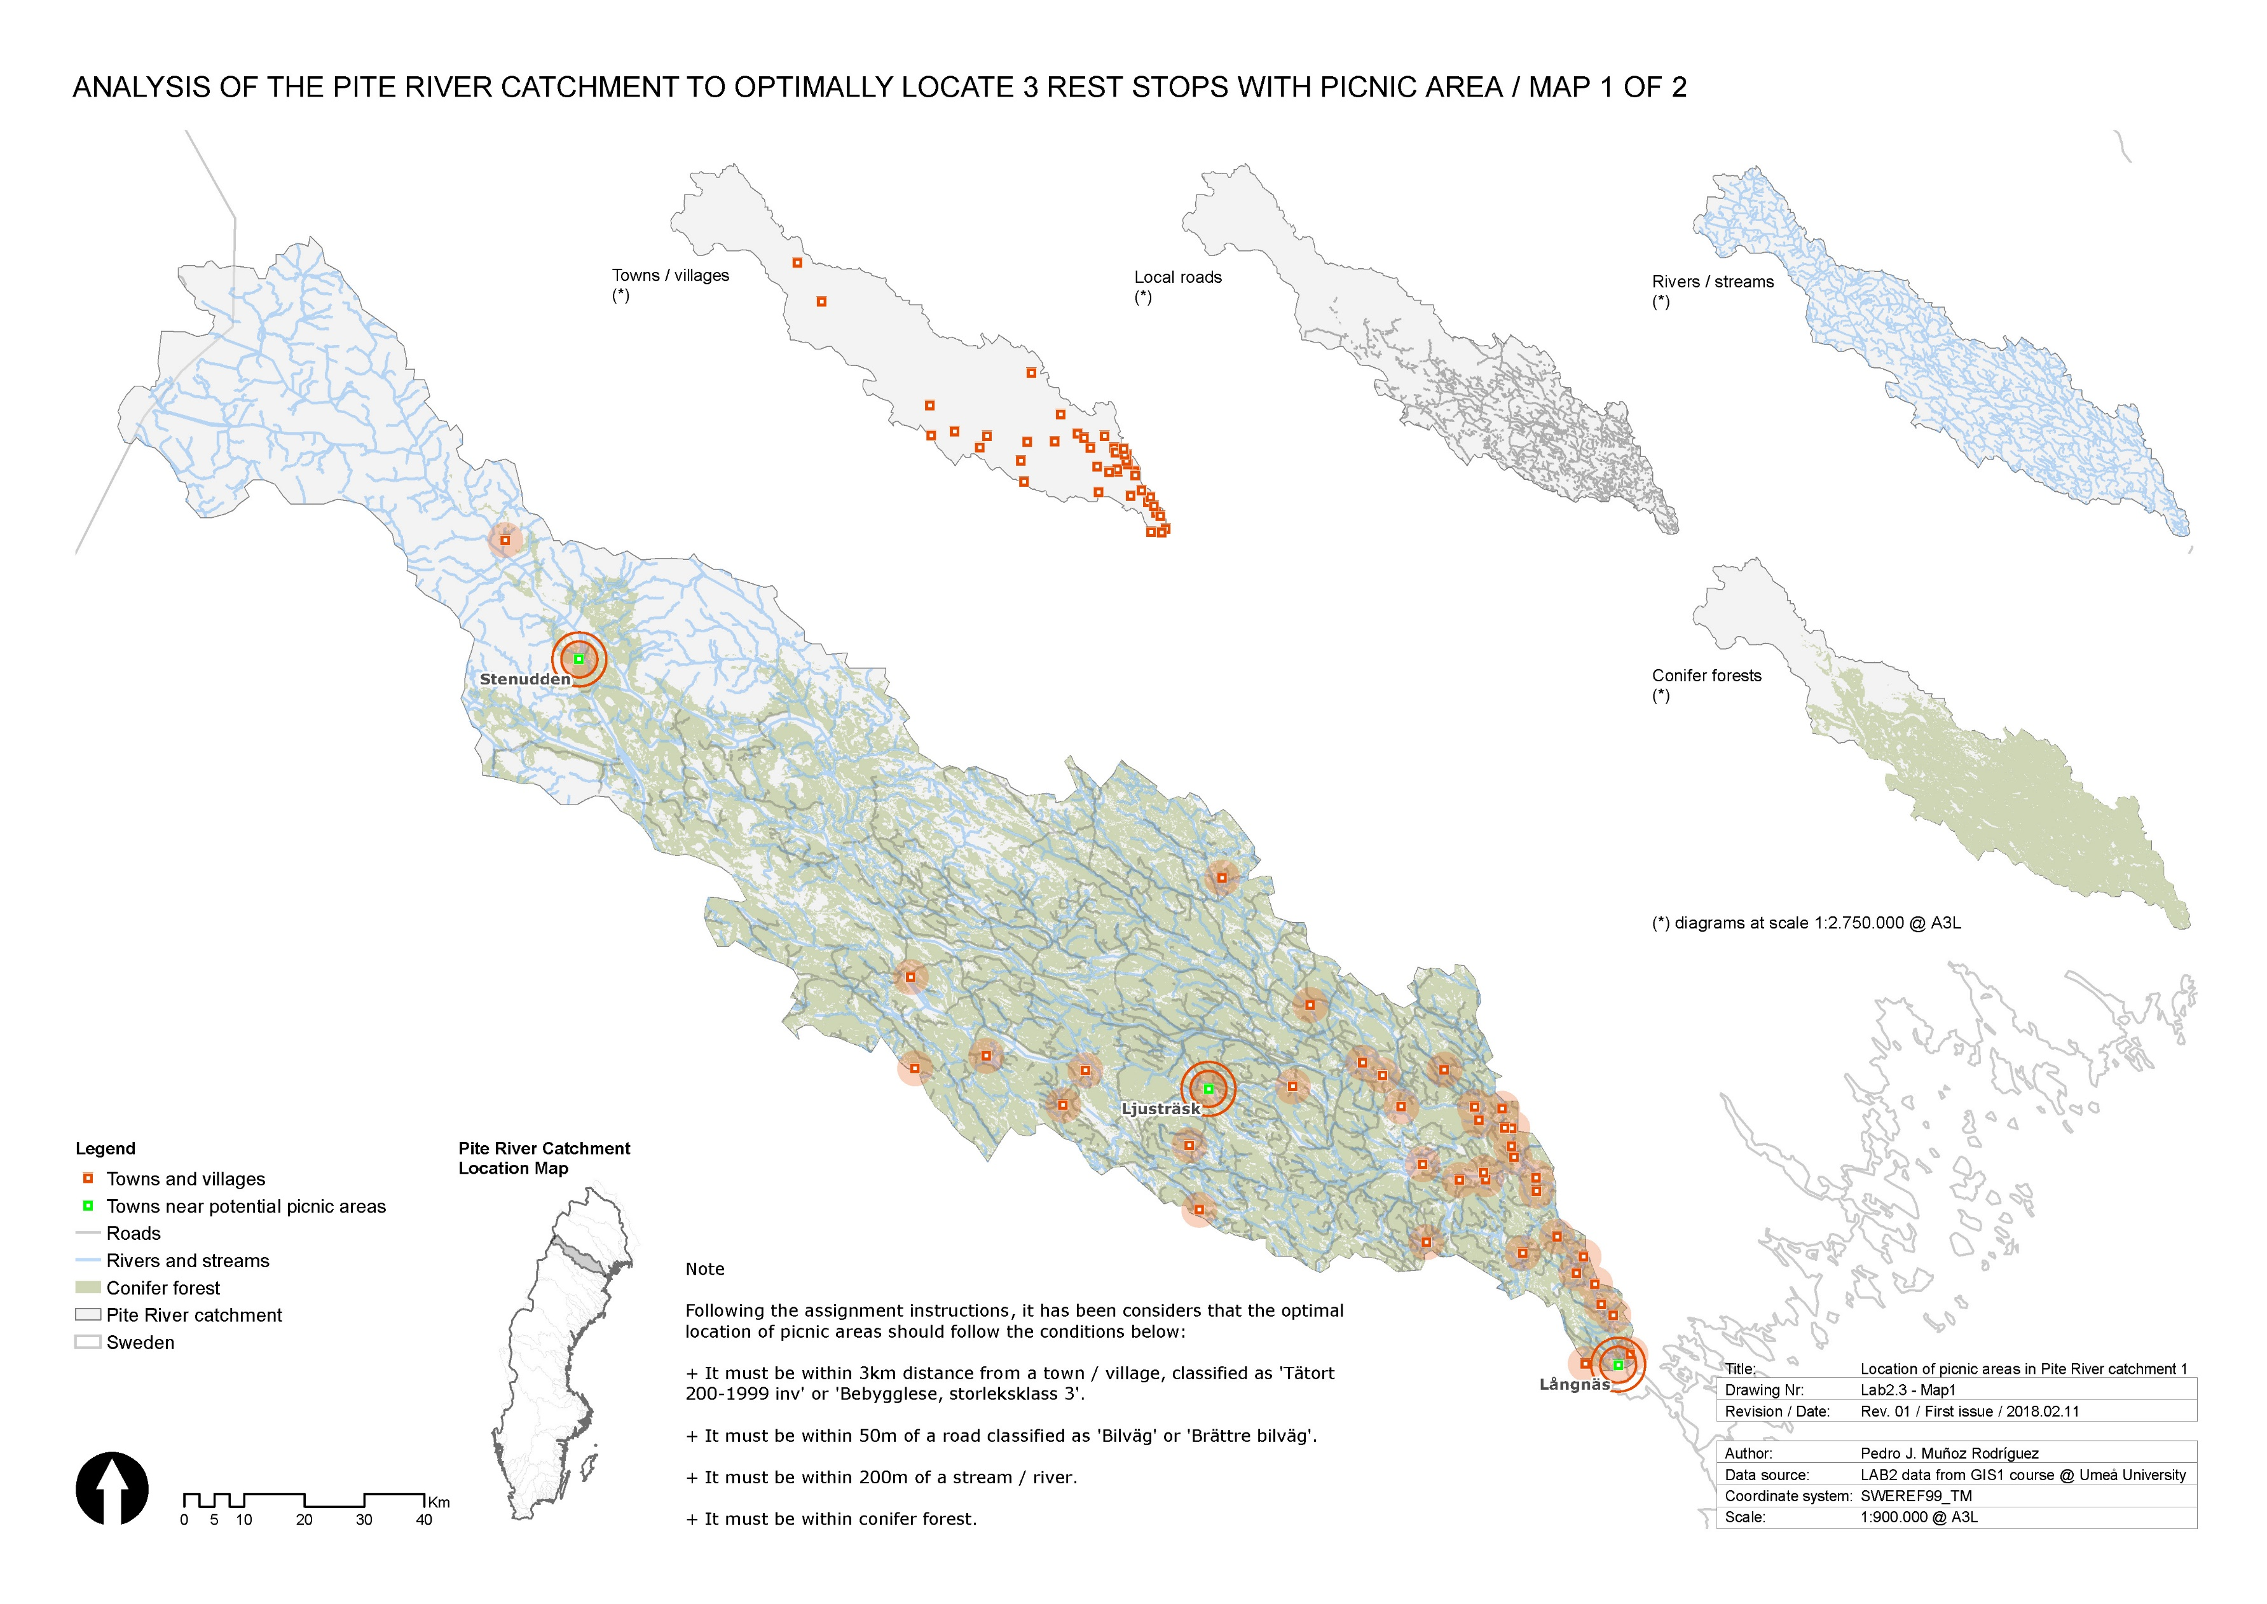

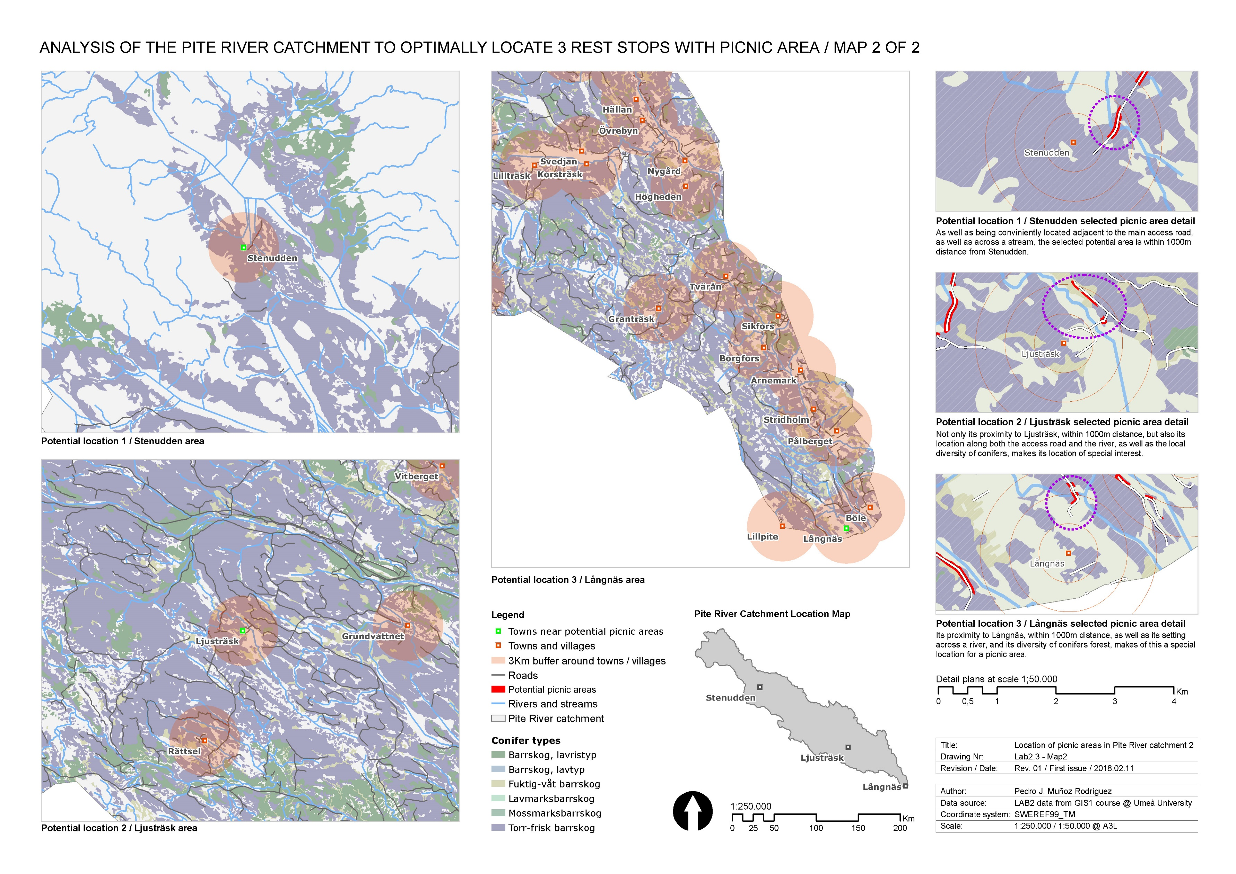

**LAB2.4 – MAP QUESTIONS / EXTRA DATA**

**LAB2.4.1**

**Your colleague wants to have a copy of your data with your final results. Create a personal geodatabase of the final files that you used to determine where the potential picnic areas should be. Make sure to include all files that were included in your map. Take a screenshot of your expanded personal geodatabase (so all the files are visible) in ArcCatalog and paste that here.**

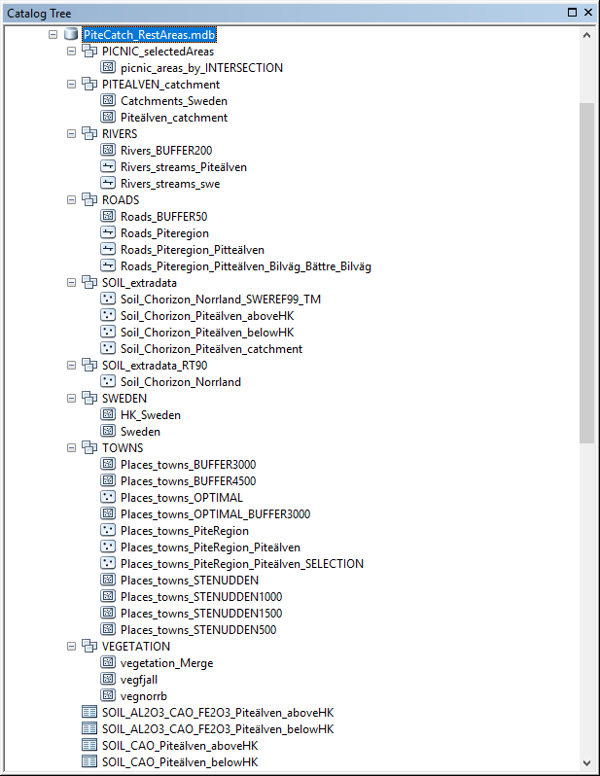

**LAB2.4.2**

**Map layout explanation: include a short explanation of your map layout. Be sure you answer the following questions: Why did you include/exclude the layers that you have in your map? How does your color scheme help your audience interpret your map? Why did you choose the inset map/map layouts that you have?**

In order to answer this question, I find convenient to separately explain the styles and scales used for each layout and each map.

In the A3 landscape **Layout 1**, I have produced a map that shows the whole Pite River catchment at scale 1:1.000.000. The purpose of this map is to show the different datasets that have been overlaid and used to calculate the requested optimal location of picnic areas across the Pite River catchment. The scale doesn’t allow much detail, but I wanted to show these information as clear as possible. The different layers used have been also depicted in four smaller maps, each of which show a single layer of information (additional to the catchment layout), in order to make even clearer the information and analysis results that can be seen in the general map.

For both the general map and the small diagrammatic maps, the range of colour used intends to be pretty neutral (forests, road, rivers), in order to make a contrast with other information, such as towns and villages, and more specifically, the towns that are adjacent to potential locations of picnic areas, which have been highlighted with buffers. These areas have been selected after analysing the information as per the assignment instructions. Thematic maps showing values by categories were not convenient in this case, such as different types of vegetation. Indeed, a unique colour has been used for the vegetation, as the only interest of this map is to show that the selected areas are within the vegetated areas. The layer with the potential picnic areas is not shown in these maps, since these areas are too small to be seen at these scales. Only the labels of the selected towns have been shown by selecting these ones to layer create a new layer with them.

An inset map that shows the location of the Pite River catchment within Sweden has been included to this layout.

In the second A3 landscape **Layout 2**, there are two sets of maps that show the 3 areas selected in a medium scale (1:250.000) and also in a closer scale (1:50.000). With the medium scale, I intended to show the context of towns selected as adjacent to potential picnic areas, such as the diversity of conifer forests and other towns and potential sites around, whereas in the closer scale, distances between elements can be seen perfectly.

Because the scale is bigger than the ones previously commented, it does make sense now to show further details, such as types of conifers (thematic categories), thicker and more intense roads and rivers, since the map user will have the chance here to start to see the potential picnic areas (whose layer has been included), and their relationship with rivers, roads and forests, as well as their proximity to different towns around. In this case, all the towns and villages have been labelled, as the context information is considered as important. At the detail scale, it was the occasion to show the specific area that could be selected as potential picnic area, as well as its proximity to the nearest town, by making buffers at 500m, 1000m, and 1500m. In this case, the map of Sweden could be removed, and, in most of the maps of this page, the map of the Pite River catchment doesn’t show up either.

In the second page, the inset map only shows the Pite River catchment, since the location of this within the map of Sweden has been already shown in the first page.